Flame Sensor

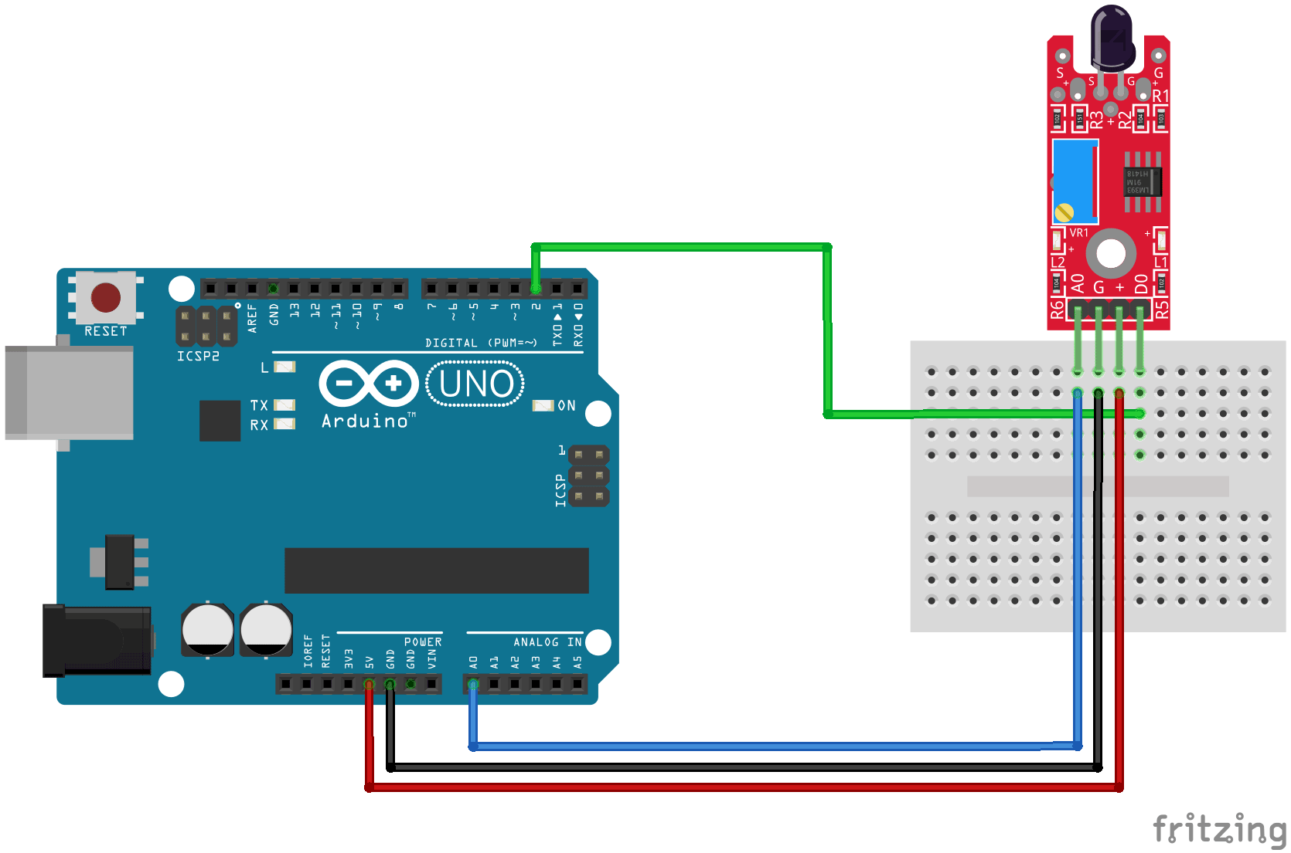

Usage: These types of sensors are used for short range fire detection and can be used to monitor projects or as a safety precaution to cut devices off / on.

Range: about 3 feet.

How it works: The flame sensor is very sensitive to IR wavelength at 760 nm ~ 1100 nm light.

Analog output (A0): Real-time output voltage signal on the thermal resistance.
Digital output (D0): When the temperature reaches a certain threshold, the output high and low signal threshold adjustable via potentiometer.

Pins:
VCC...... Positive voltage input: 5v for analog 3.3v for Digital.
A0.......... Analog output
D0......... Digital output
GND..... Ground

The following code maps and reads the analog values given by the flame sensor (0-1024). The stock flame sensor will have the following reaction with this code: If holding a flame within 1.5 feet in front of the sensor; "case 0" will be activated and " ** Close Fire ** " will be sent to the serial monitor. If holding a flame between 1.5 feet and 3 feet in front of the sensor; "case 1" will be activated and " **Distant Fire** " will be sent to the serial monitor. If no flame is detected in front of the sensor; "case 2" will be activated and " No Fire " will be sent to the serial monitor.

const int sensorMin = 0; // sensor minimum
const int sensorMax = 1024; // sensor maximum

void setup() {
// initialize serial communication @ 9600 baud:
Serial.begin(9600);
}
void loop() {
// read the sensor on analog A0:
int sensorReading = analogRead(A0);
// map the sensor range (four options):
// ex: 'long int map(long int, long int, long int, long int, long int)'
int range = map(sensorReading, sensorMin, sensorMax, 0, 3);

// range value:
switch (range) {
case 0: // A fire closer than 1.5 feet away.
Serial.println("** Close Fire **");
break;
case 1: // A fire between 1-3 feet away.
Serial.println("** Distant Fire **");
break;
case 2: // No fire detected.
Serial.println("No Fire");
break;
}
delay(1); // delay between reads
}

